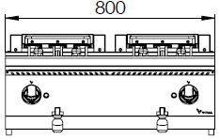
ELECTRIC FRYER WITH DOUBLE TANK

700'
COOKING SERIE

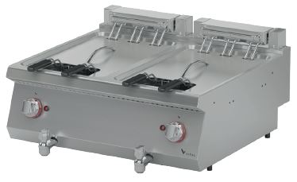

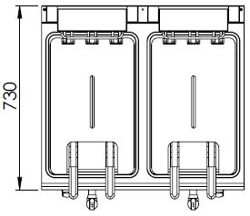

The tank of the fruer is made of press and the cornes are rounded which makes it easy to clean.
The stainless steel body makes the device durable and enduring.
The capacity of the tank is 13+13 liters.
The release valve located under the oil tank enables secure and easy discharging of the oil.
The temperature of the oil is adjustable up to 180°C through the thermostat. The safety thermostat prevents overheating.
The basket hanger mechanism ensures the straining of the oil after the frying process.
The movable resistance mechanism provides an easy cleaning and the safety switch located inside turns off the resistance’s energy to have a secure operation.
The thickness of the upper panel is 1,5 mm and made of AISI 304 stainless steel.
The body sheets are 1 mm and made of Scotch Brite stainless steel.
Can be used on worktops or cupboards.

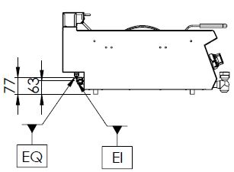

EI=ELECTRIC INLET
EQ=GROUNDING CONNECTION

MODEL | DESCRIPTION | DIMENSIONS | TOTAL POWER | ELECTRIC VOLTAGE /  CABLE CROSS SECTION | WEIGHT
EFP7020 | ELECTRIC FRYER | 800X730X280 | 24 kW | 380-400 VAC 3N 50 Hz  /  5X6 mm² | 39 kg net
 |  | 820X800X450 Package dimension |  |  | 48 kg  Gross weight

HEADQUARTER |  | FACTORY
Plevne Caddesi No.40/C |  | Taşpınar Mevkii No.154
Gülveren-Mamak/ANKARA |  | Çubuk/ANKARA
Tel . | +90 312 363 94 93 | Tel . | +90 312 837 76 72
Fax. | +90 312 363 94 92 | Fax. | +90 312 837 73 38
www.mutasgroup.com / info@vitalmutfak.com

