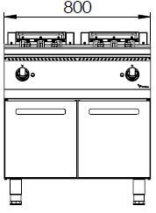
ELECTRIC FRYER WITH DOUBLE TANK

900'
COOKING SERIE
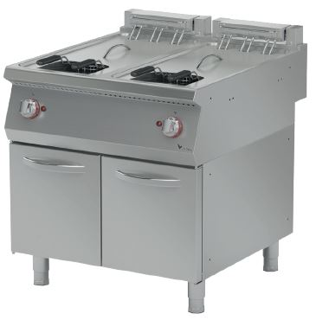

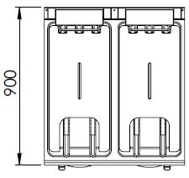

The tank of the fryer is made of press and the cornes are rounded which makes it easy to clean.
The stainless steel body makes the device durable and enduring.
The capacity of the tanks is 25+25 liters.
The release valve located under the oil tank enables secure and easy discharging of the oil.
The temperature of the oil is adjustable up to 180°C through the thermostat. The safety thermostat prevents overheating.
The basket hanger mechanism ensures the straining of the oil after the frying process.
The movable resistance mechanism provides an easy cleaning and the safety switch located inside turns off the resistance’s energy to have a secure operation.
The thickness of the upper panel is 1,5 mm and made of AISI 304 stainless steel.
The body sheets are 1 mm and made of Scotch Brite stainless steel.
Can be used on worktops or cupboards.

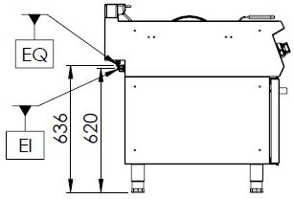

EI=ELECTRIC INLET
EQ=GROUNDING CONNECTION

MODEL | DESCRIPTION | DIMENSION | TOTAL POWER | ELECTRIC VOLTAGE /  CABLE CROSS SECTION | WEIGHT
EFP9020 | ELECTRIC FRYER | 800X900X850 | 33,6 kW | 380-400 VAC 3N 50 Hz  /  5X10 mm² | 110 kg net
 |  | 820X960X1100 Package dimension |  |  | 120 kg  Gross weight

HEADQUARTER |  | FACTORY
Plevne Caddesi No.40/C |  | Taşpınar Mevkii No.154
Gülveren-Mamak/ANKARA |  | Çubuk/ANKARA
Tel . | +90 312 363 94 93 | Tel . | +90 312 837 76 72
Fax. | +90 312 363 94 92 | Fax. | +90 312 837 73 38
www.mutasgroup.com / info@vitalmutfak.com

