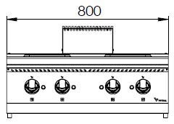

**4 SQUARE ELECTRIC HOT PLATE**

**700'**

**COOKING SERIE**



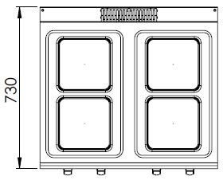

The stainless steel body makes the device durable and enduring.

Easy to clean through its rounded upper surface.

The device is produced with special molds and pressed top.

The monoblock worktop increases the durability and ensures an easy cleaning.

The temperature control of the plates are made with 6 level of heating. This allows the user to cook and hold.

Square plates of 200*200 mm with 2600W power.

The thickness of the upper part is 1,5 mm AISI stainless steel.

The body sheets are 1 mm Scotch Brite stainless steel.

Can be used on countertop or on base cupboard.

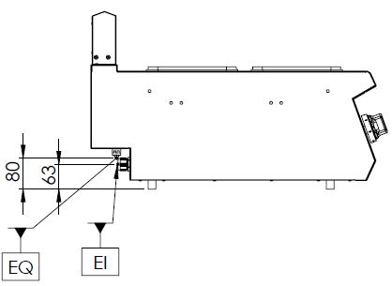

EI=ELECTRIC INLET

EQ=GROUNDING CONNECTION

|  |  |  |  |  |  |
| --- | --- | --- | --- | --- | --- |
| **MODEL** | **DESCRIPTION** | **DIMENSIONS** | **TOTAL POWER** | **ELECTRIC POWER / CABLE CROSS SECTION** | **WEIGHT** |
| EKO7020K | ELECTRIC HOT PLATE | 800X730X280 | 10,4 kW | 380-400 VAC 3N 50 Hz  /  5X4 mm2 | 40 kg net |
| 820X800X450 Package dimensions | 49 kg  Gross weight |



|  |  |  |  |
| --- | --- | --- | --- |
| **HEADQUARTER** | | **FACTORY** | |
| Plevne Caddesi No.40/C | | Taşpınar Mevkii No.154 | |
| Gülveren-Mamak/ANKARA | | Çubuk/ANKARA | |
| Tel . | +90 312 363 94 93 | Tel . | +90 312 837 76 72 |
| Fax. | +90 312 363 94 92 | Fax. | +90 312 837 73 38 |
| [**www.mutasgroup.com**](http://www.mutasgroup.com/) **/** [**info@vitalmutfak.com**](mailto:info@vitalmutfak.com) | | | |