

**ELECTRIC PASTA COOKER W/ SINGLE TANK**

**900'**

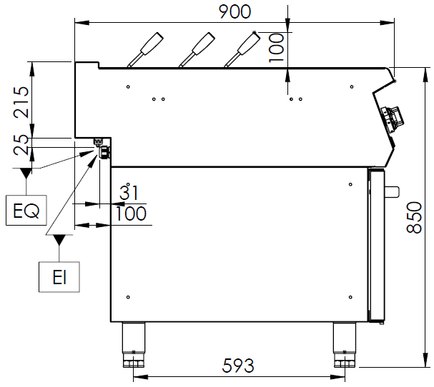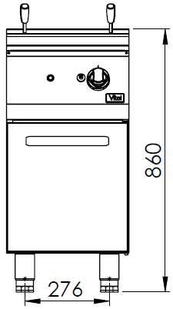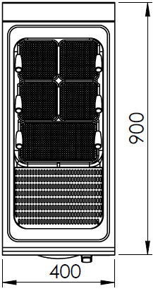

**COOKING SERIE**



The stainless steel body makes the device durable and enduring.

Easy to clean through rounded corners.

The device is produced with special molds and press printing.

The monoblock worktop increases the durability and ensures an easy cleaning.

The special designed resistances located under the cooking surface provide homogeneous temperature distribution inside the pan.

The safety thermostat prevents overheating and ensures safety.

The water drain valve ensures an easy drainage.

The water inlet tap provides quick and easy filling of the tank.

The capacity of the tank is 25 liters.

The temperature is made with 3 level step switch.

The body sheets are 1 mm and made of Scotch Brite stainless steel.

EI=ELECTRIC INLET

EQ=GROUNDING CONNECTION

WI=WATER INLET

|  |  |  |  |  |  |
| --- | --- | --- | --- | --- | --- |
| **MODEL** | **DESCRIPTION** | **DIMENSIONS** | **TOTAL POWER** | **ELECTRIC VOLTAGE /**  **CABLE CROSS SECTION** | **WEIGHT** |
| EMF9010 | ELECTRIC PASTA COOKER | 400X900X850 | 10,5 kW | 380-400 VAC 3N 50 Hz  /  5X4 mm2 | 50 kg net |
| 420X960X1100 Package dimension | 58 kg  Gross weight |



|  |  |  |  |
| --- | --- | --- | --- |
| **HEADQUARTER** | | **FACTORY** | |
| Plevne Caddesi No.40/C | | Taşpınar Mevkii No.154 | |
| Gülveren-Mamak/ANKARA | | Çubuk/ANKARA | |
| Tel . | +90 312 363 94 93 | Tel . | +90 312 837 76 72 |
| Fax. | +90 312 363 94 92 | Fax. | +90 312 837 73 38 |
| [**www.mutasgroup.com**](http://www.mutasgroup.com/) **/** [**info@vitalmutfak.com**](mailto:info@vitalmutfak.com) | | | |