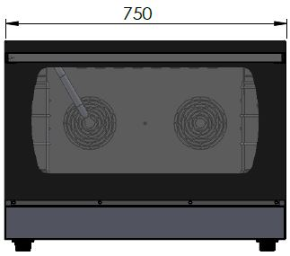
ELECTRIC CONVECTION PATISSERIE OVEN

PATISSERIE OVENS
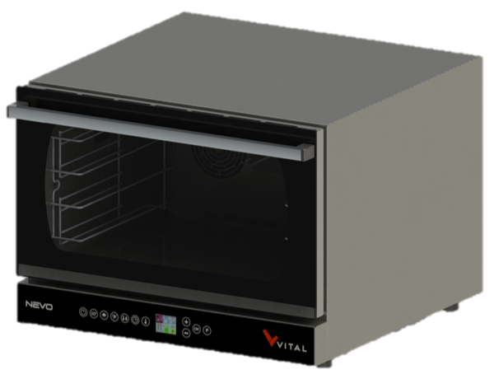

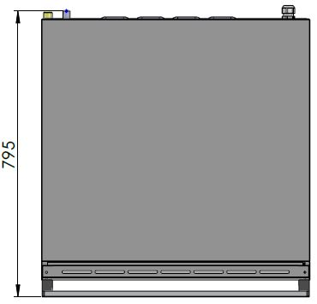

The stainless steel body makes the device durable and enduring.
Easy to clean through its rounded internal chamber corners.
Its openable internal glass ensures easy cleaning.
It is composed with high temperature resistant double glazing.
The insulation material around the cabinet minimizes heat loss and saves energy.
The special door seal prevents heat transition from the door and saves energy.
Double direction rotatable stainless steel fan ensures homogeneous heat distribution in the cabinet.
The safety thermostat prevents overheating of the cabinet.
Offers manual or automatic humidity control.
All functions are digitally controlled.
Offers a wide cooking range with its up to 180 minutes adjustable cooking time.
Prepares the oven for the next cooking with its cooling function.
99 programmable cooking memories with 4 adjustable cooking stages.
Safety door switch stops the cooking process in case the door opens.
Halogen lamps are used for the internal lightening.
With a capacity of 4 x 40x60 mm or 4 x GN 1/1 40 mm trays.

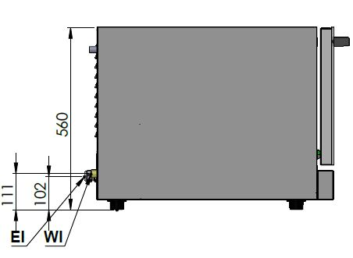

EI=ELECTRIC INLET
WI=WATER INLET

MODEL | DESCRIPTION | DIMENSIONS | TOTAL POWER  /  FAN POWER | ELECTRIC VOLTAGE /  CABLE CROSS SECTION | WATER INLET /  WATER PRESSURE | WEIGHT
NEVO-04E | ELECTRIC ONVECTION PATISSERIE OVEN | 750X795X560 | 7 kW  /  2X0,3 = 0,6 kW | 380-400 VAC 3N 50 Hz  220-230 VAC 1N 50 Hz  /  5X2,5 mm²  3X6 mm² | R 3/4  /  1,5-4 bar | 70 kg net
 |  | 770X820X610  Package dimension |  |  |  | 80 kg  Gross weight
HEADQUARTER |  | FACTORY
Plevne Caddesi No.40/C |  | Taşpınar Mevkii No.154
Gülveren-Mamak/ANKARA |  | Çubuk/ANKARA
Tel . | +90 312 363 94 93 | Tel . | +90 312 837 76 72
Fax. | +90 312 363 94 92 | Fax. | +90 312 837 73 38
www.mutasgroup.com / info@vitalmutfak.com

