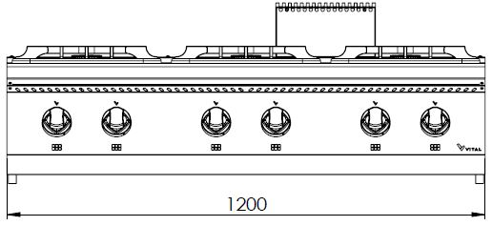
GAS 6 OPEN BURNER

700'
COOKING SERIE

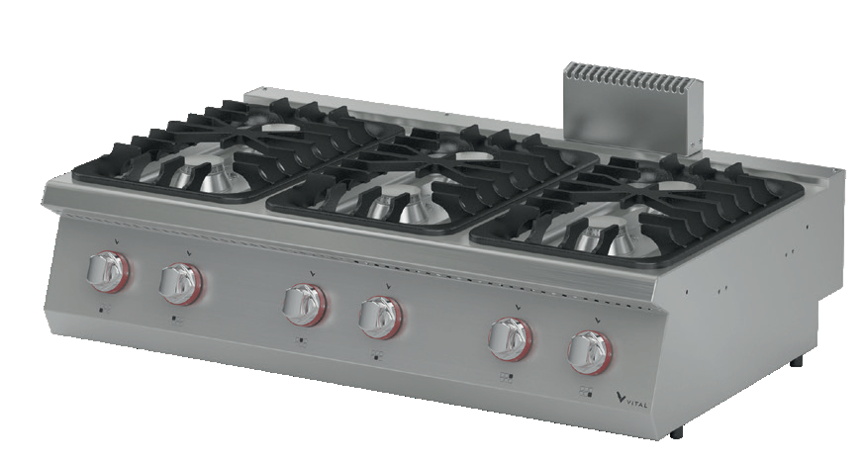

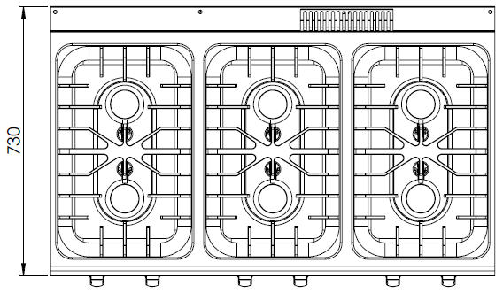

The stainless steel body makes the device durable and enduring.
Easy to clean through its rounded upper surface.
All burners are produced with special molds and pressed top.
The monoblock worktop increases the durability and ensures an easy cleaning.
In order to put pots pans etc on the stove burners, cast iron cooker burners are available.
Pilot flame taps with safety device have been used.
High efficiency and low gas emission burners have been used.
The thickness of the upper part is 1,5 mm AISI stainless steel.
The body sheets are 1 mm Scotch Brite stainless steel.
Can be used on countertop or on base cupboard.
Can be operated with LPG or natural gas.

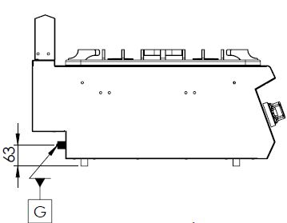

G=GAS INLET

MODEL | DESCRIPTION | DIMENSIONS | TOTAL POWER | GAS CONSUMPTION |  | WEIGHT
GKO7030 | GAS BURNER | 1200X730X280 | 45 kW | 4.762 max. / 2.500 min. | 3.549 max. /1.863 min. | 73 kg net
 |  | 1220X800X450 Package dimension |  | G20(m³/h) | G30 (kg/h) | 88 kg Gross weight

HEADQUARTER |  | FACTORY
Plevne Caddesi No.40/C |  | Taşpınar Mevkii No.154
Gülveren-Mamak/ANKARA |  | Çubuk/ANKARA
Tel . | +90 312 363 94 93 | Tel . | +90 312 837 76 72
Fax. | +90 312 363 94 92 | Fax. | +90 312 837 73 38
www.mutasgroup.com / info@vitalmutfak.com

