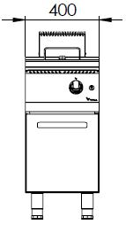

**GAS FRYER W/ SINGLE TANK**

**900'**

**COOKING SERIE**



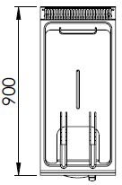

The tank of the fruer is made of press and the cornes are rounded which makes it easy to clean.

The stainless steel body makes the device durable and enduring.

The capacity of the tank is 25 liters.

The release valve located under the oil tank enables secure and easy discharging of the oil.

The temperature of the oil is adjustable up to 190 oC.

The basket hanger mechanism ensures the straining of the oil after the frying process.

Gas valves with safety valves provide safe operation.

A thermocouple for flame control is available.

The thickness of the upper panel is 1,5 mm and made of AISI 304 stainless steel.

The body sheets are 1 mm and made of Scotch Brite stainless steel. Pilot valve with safety valve and thermostathave been used.

Can be operated with LPG or natural gas.

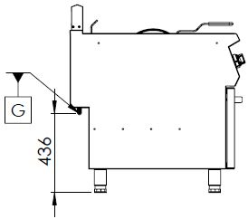

G=GAS INLET

|  |  |  |  |  |  |  |
| --- | --- | --- | --- | --- | --- | --- |
| **MODEL** | **DESCRIPTION** | **DIMENSIONS** | **TOTAL POWER** | **GAS CONSUMPTION** | | **WEIGHT** |
| GFP9010 | GAS FRYER | 400X900X850 | 16 kW | 1.693 max. / 0.889 min. | 1.262 max. /0.662 min. | 65 kg net |
| 420X960X1100 Package dimension | G20(m3/h) | G30 (kg/h) | 73 kg  Gross weight |





|  |  |  |  |
| --- | --- | --- | --- |
| **HEADQUARTER** | | **FACTORY** | |
| Plevne Caddesi No.40/C | | Taşpınar Mevkii No.154 | |
| Gülveren-Mamak/ANKARA | | Çubuk/ANKARA | |
| Tel . | +90 312 363 94 93 | Tel . | +90 312 837 76 72 |
| Fax. | +90 312 363 94 92 | Fax. | +90 312 837 73 38 |
| [**www.mutasgroup.com**](http://www.mutasgroup.com/) **/** [**info@vitalmutfak.com**](mailto:info@vitalmutfak.com) | | | |