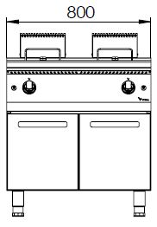
GAS FRYER W/ DOUBLE TANK

900'
COOKING SERIE
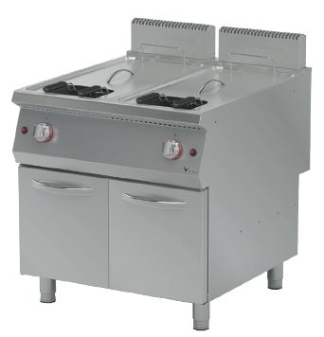

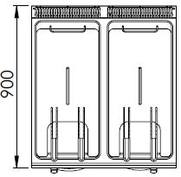

The tank of the fruer is made of press and the cornes are rounded which makes it easy to clean.
The stainless steel body makes the device durable and enduring.
The capacity of the tank is 25+25 liters.
The release valve located under the oil tank enables secure and easy discharging of the oil.
The temperature of the oil is adjustable up to 190 ºC.
The basket hanger mechanism ensures the straining of the oil after the frying process.
Gas valves with safety valves provide safe operation.
A thermocouple for flame control is available.
The thickness of the upper panel is 1,5 mm and made of AISI 304 stainless steel.
The body sheets are 1 mm and made of Scotch Brite stainless steel. Pilot valve with safety valve and thermostat have been used.
Can be operated with LPG or natural gas.

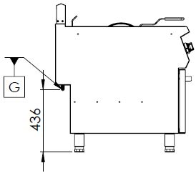

G=GAS INLET

MODEL | DESCRIPTION | DIMENSIONS | TOTAL POWER | GAS CONSUMPTION |  | WEIGHT
GFP9020 | GAS FRYER | 800X900X850 | 42 kW | 3.387 max. / 1.778 min. | 2.524 max. /1.235 min. | 102 kg net
 |  | 820X960X1100 Package dimension |  | G20(m³/h) | G30 (kg/h) | 112 kg  Gross weight

HEADQUARTER |  | FACTORY
Plevne Caddesi No.40/C |  | Taşpınar Mevkii No.154
Gülveren-Mamak/ANKARA |  | Çubuk/ANKARA
Tel . | +90 312 363 94 93 | Tel . | +90 312 837 76 72
Fax. | +90 312 363 94 92 | Fax. | +90 312 837 73 38
www.mutasgroup.com / info@vitalmutfak.com

