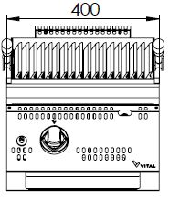
GAS LAVASTONE GRILL

900'
COOKING SERIE
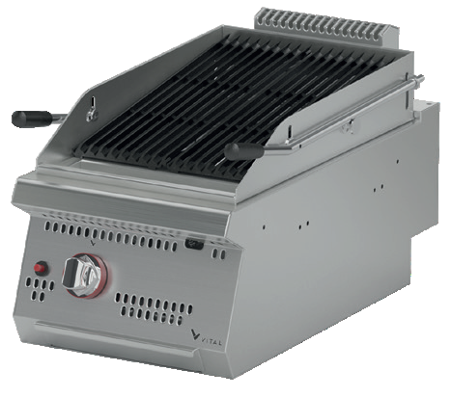

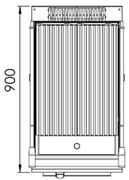

All grills are designed for homogeneous temperature on the cooking surface.
Easy to clean through its rounded upper surface.
The device is produced with special molds and pressed top.
The stainless steel body makes the device durable and enduring.
The specially designed cast gril makes the waste oil accumulating on the discharge at the front.
Adjustable cooking surface temperature.
Safety gas valves provide safe operation.
A thermocouple for flame control is available.
Has a piezoelectric ignition system.
The waste oil is collected on the removable container which makes it easy to clean.
The thickness of the upper part is 1,5 mm AISI stainless steel.
The body sheets are 1 mm Scotch Brite stainless steel.
Can be used on countertop or on base cupboard.
Can be operated with LPG or natural gas.

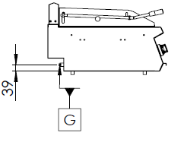

G=GAS INLET

MODEL | DESCRIPTION | DIMENSIONS | TOTAL POWER | GAS CONSUMPTION |  | WEIGHT
GLI9010 | GAS LAVASTONE GRILL | 400X900X280 | 9.5 kW | 1.005 max. / 0.528 min. | 0.749 max. /0.393 min. | 67 kg net
 |  | 420X960X530 Package dimension |  | G20(m³/h) | G30 (kg/h) | 75 kg Gross weight

HEADQUARTER |  | FACTORY
Plevne Caddesi No.40/C |  | Taşpınar Mevkii No.154
Gülveren-Mamak/ANKARA |  | Çubuk/ANKARA
Tel . | +90 312 363 94 93 | Tel . | +90 312 837 76 72
Fax. | +90 312 363 94 92 | Fax. | +90 312 837 73 38
www.mutasgroup.com / info@vitalmutfak.com

