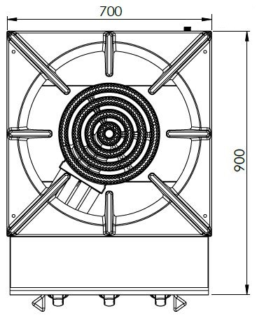

**OTHER COOKING APPLIANCES**

**4 BURNER GAS LOW STOVE**



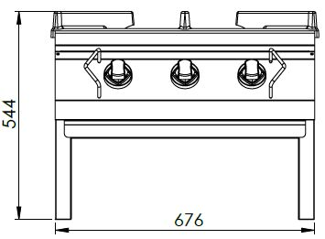

The stainless steel body makes the device durable and enduring.

Safety valve faucet.

High efficiency and low gas emission burners. The internal burner is 10 kW, the middle and external burners are 11 kW powered.

Cast iron pan grids.

Can be used with LPG or natural gas.

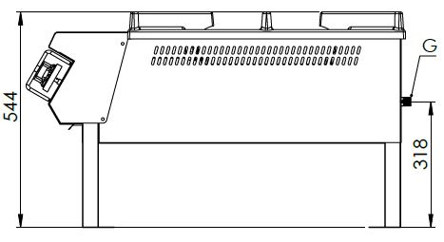

G=GAS INLET

|  |  |  |  |  |  |  |
| --- | --- | --- | --- | --- | --- | --- |
| **MODEL** | **DESCRIPTION** | **DIMENSIONS** | **TOTAL POWER** | **GAS CONSUMPTION** | | **WEIGHT** |
| VYO78 | GAS LOW STOVE | 700X900X550 | 32 kW | 3.387 max. / 1.778 min. | 2.524 max. /1.325 min. | 58 kg net |
| 720X950X650 Package dimension | G20(m3/h) | G30 (kg/h) | 66 kg Gross weight |



|  |  |  |  |
| --- | --- | --- | --- |
| **HEADQUARTER** | | **FACTORY** | |
| Plevne Caddesi No.40/C | | Taşpınar Mevkii No.154 | |
| Gülveren-Mamak/ANKARA | | Çubuk/ANKARA | |
| Tel . | +90 312 363 94 93 | Tel . | +90 312 837 76 72 |
| Fax. | +90 312 363 94 92 | Fax. | +90 312 837 73 38 |
| [**www.mutasgroup.com**](http://www.mutasgroup.com/) **/** [**info@vitalmutfak.com**](mailto:info@vitalmutfak.com) | | | |