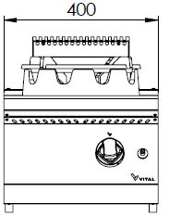
GAS WOK BURNER

700'
COOKING SERIE

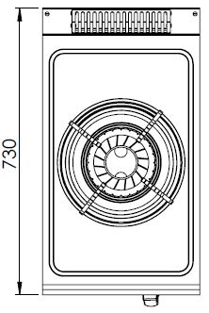

The stainless steel body makes the device durable and enduring.
Easy to clean through its rounded upper surface.
All burners are produced with special molds and pressed top.
The monoblock worktop increases the durability and ensures an easy cleaning.
High efficiency and low gas emission burners have been used.
Safety device pilot flame taps have been used.
In order to put pots, pans etc on the burner, round mouldings are available.
Piezo lighter ignition system.
The thickness of the upper part is 1,5 mm AISI stainless steel.
The body sheets are 1 mm Scotch Brite stainless steel.
Can be used on countertop or on base cupboard.
Can be operated with LPG or natural gas.

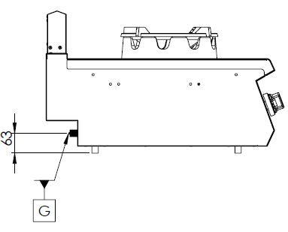

G=GAS INLET

MODEL | DESCRIPTION | DIMENSIONS | TOTAL POWER | GAS CONSUMPTION |  | WEIGHT
GKW7010 | GAS WOK BURNER | 400X730X280 | 13.5 kW | 1.429 max. / 0.750 min. | 1.066 max. /0.559 min. | 40 kg net
 |  | 420X800X580 Package dimension |  | G20(m³/h) | G30 (kg/h) | 47 kg Gross weight

HEADQUARTER |  | FACTORY
Plevne Caddesi No.40/C |  | Taşpınar Mevkii No.154
Gülveren-Mamak/ANKARA |  | Çubuk/ANKARA
Tel . | +90 312 363 94 93 | Tel . | +90 312 837 76 72
Fax. | +90 312 363 94 92 | Fax. | +90 312 837 73 38
www.mutasgroup.com / info@vitalmutfak.com

